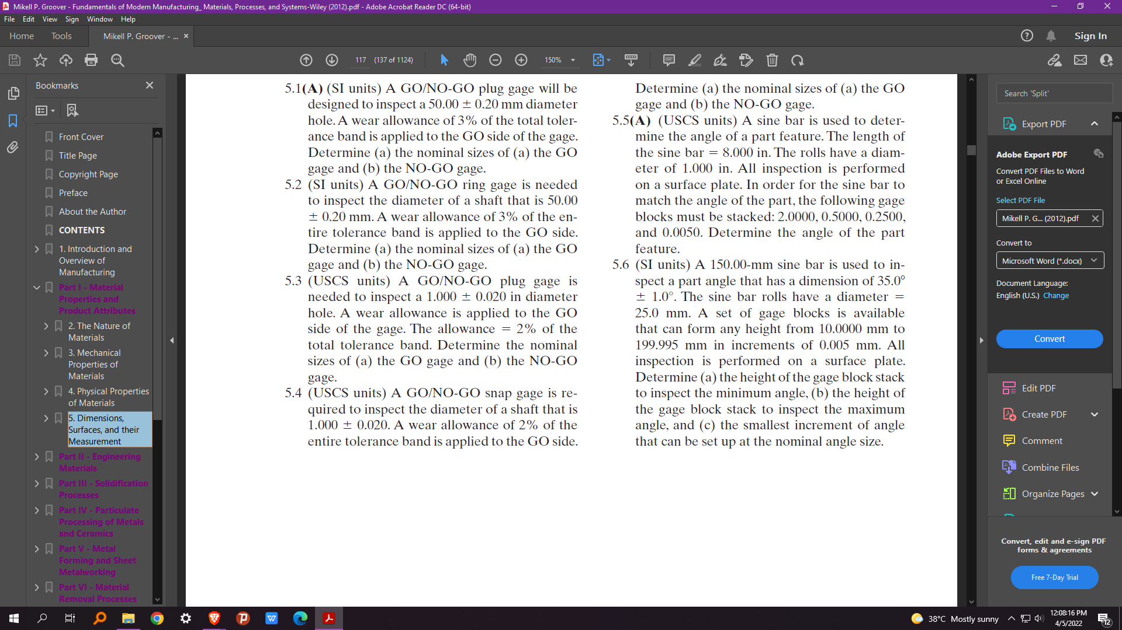Determine the nominal sizes of the a) GO gage and b) NOGO gage.